LEXINGTON Double Plate Bed

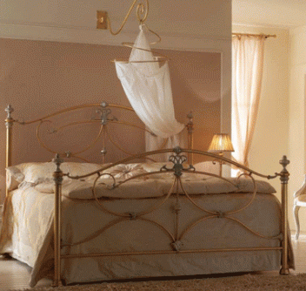

|  |
| --- |
| **DESCRIPTION** |
| LEXINGTON introduces bed with polyester steel with anti chorded rusts protection. This set of bed is sure to create the perfect look in large flats where it is difficult to lift the bed and take it to top floor. The rich steel is perfect for the use of this purpose because it is light and easy lift able. Let’s not forget because it is light doesn’t mean it is not strong enough. |

|  |  |  |
| --- | --- | --- |
| **Price** | **3650$** | |
| **Dimensions** | **H** x **W** x **L** | **30in x 40in x 75in** |
| **Features** | **Light steel which proves to be very strong is easily carried to the top floor.** | |
| **Finished** | **Polished antirust Surface** | |
| **Available in** | **Golden and Red** | |